Tenda MW5s-How to add new MW5s into existing mesh network system?

User Scenario: I want to buy another suite MW5s to extend my WiFi coverage. What should I do?

Step 1:
Use mobile phone to connect with MW5s WiFi signal. Open App, tap “Settings” > “Add nova”.

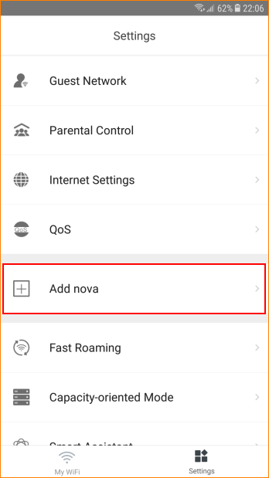

Step 2: Place the nova in an open area and keep it within two rooms (10 meters) away from existing nodes.

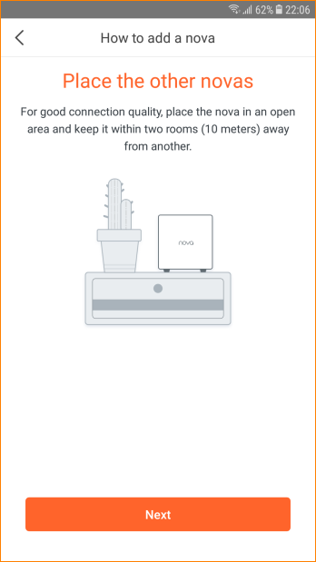

Step 3: Power it on.

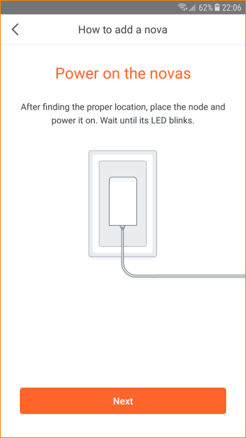

Step 4: Scan QR code or enter SN code next to LAN port of the node after startup completes (LED blinks green)

Step 5: Wait for 30-40 seconds, it will show “Added”.

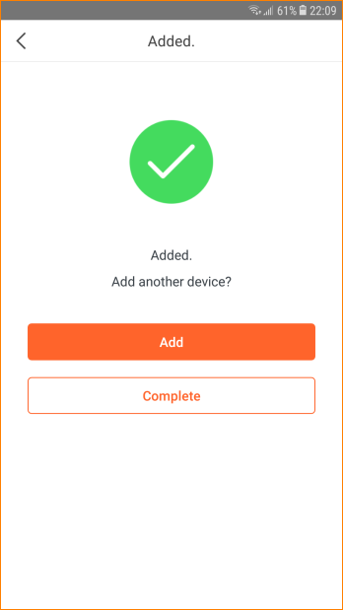

Step 6: Tap “Complete” to go back to home page.

Note:
If failed to add, please do as follows:

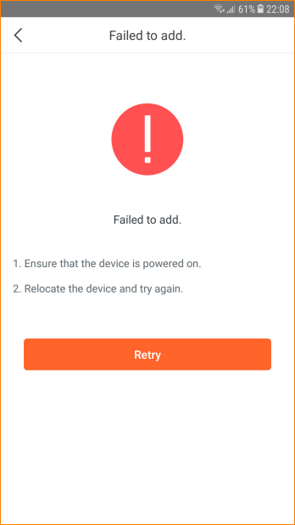

1. Ensure startup completes.
2. Ensure the node is placed within WiFi coverage of existing network.
3. Ensure you scan complete QR code.
4. You can enter SN code manually if the QR code is damaged.

